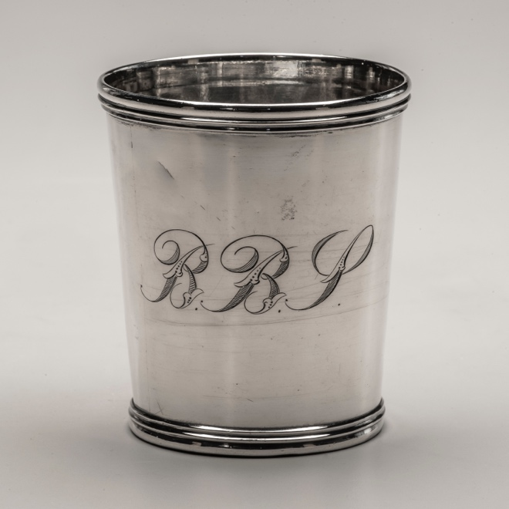
“The Absconded Jeweler:” George Sharp, Jr.’s Sterling Housewares and Tarnished Reputation
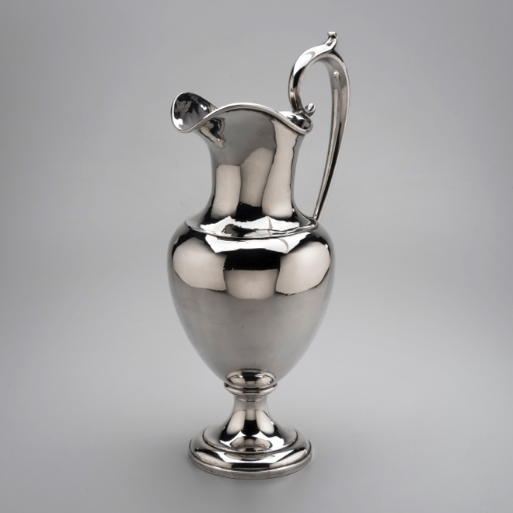

Victoria Hensley
Summer Institute Fellow 2019

“Now is the time for Bargains. Call early and buy at hard pan prices. I mean business. The owners of the goods want the money for them and I want my commissions.” When George Sharp, Jr. placed an advertisement in The Atlanta Constitution with a special announcement for his major sale during the summer of 1876 he spoke not as an artisan, but as a merchant. The goods he hoped to sell included watches, diamonds, jewelry, and silverwares. The goods were manufactured elsewhere in the country and imported into Atlanta, a New South railroad hub rapidly emerging as a major post-war southern business district city. Sharp’s store, located on Whitehall Street in the exploding Atlanta, featured all kinds of jewelry and silver goods. While the 1876 advertisement placed by Sharp might not seem unusual or conspicuous for a jewelry and silver merchant attempting to keep his trade productive in the midst of a national economic recession and Reconstruction, the particular advertisement could be a hint to Sharp’s financial troubles. Less than a year later, in April 1877, Sharp fled Atlanta while nearly $50,000 in debt. Sharp’s story provides an example of the challenges southern craftsmen faced in the mid-nineteenth century, as their craft and place in the economic system changed in the face of the emerging, corporate capitalist order of post-Civil War America. This research attempts to unpack the challenges Sharp faced in order to understand how an award-winning silversmith and jeweler found himself so far in debt he ran away from the life and region he knew.
Within the collections of the Museum of Early Southern Decorative Arts are two silver pieces associated with Sharp that speak to two distinct phases of his career. The first is a silver beaker, dated as sometime between 1857 and 1864, which has the mark of “G. Sharp Jr./ Danville. KY.” Both the top and base of the beaker feature an applied triple band. The body of the beaker is rolled sheet silver, with the seam visible on the body. The beaker is engraved with the letters “B.B.P.” The script is decorative, with leaves and diagonal fill lines.
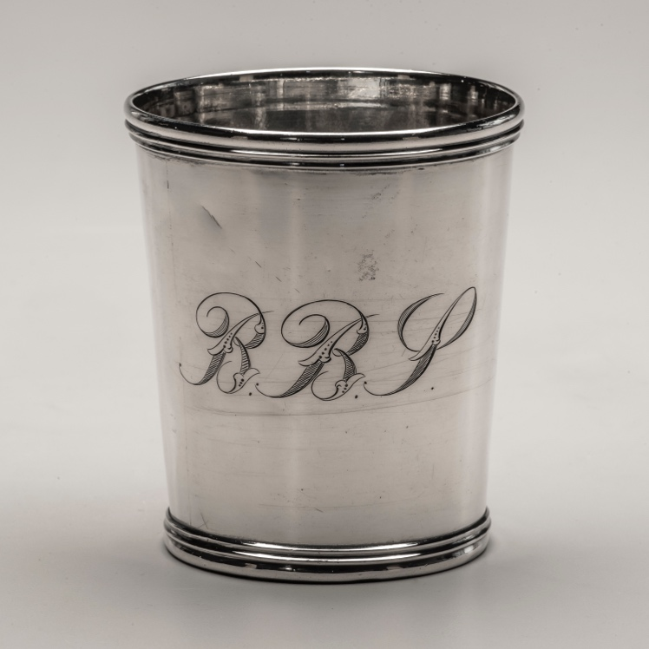
Figure 1. Beaker by George Sharp, Jr., Danville, Kentucky, 1857-1864, MESDA Collection (5967)
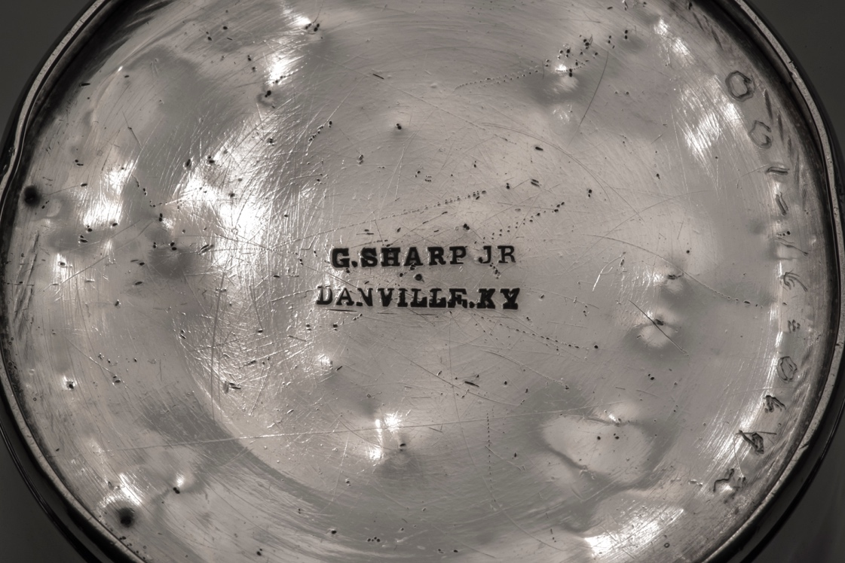
Figure 2. Maker's Mark on beaker by George Sharp, Jr.,, Danville, Kentucky, 1857-1864, MESDA Collection (5967)
Sharp’s Danville object documents the first phase of his career. He was born in Winchester, Virginia in 1835 to George Sharp, Sr. and Elizabeth Brown Sharp. Winchester, at the time, was a center for silversmiths and trade along the Great Wagon Road. His father, according to the 1850 Census, however, worked as a dentist. Virginia silversmith scholar Catherine B. Hollan also listed Sharp’s father as a silversmith, but also noted Sharp’s father was never listed in the census as a silversmith. Perhaps the intersection of silversmithing and dental work, in the form of crowns and dentures, influenced Sharp’s trade. Sharp could have been drawn to the silversmithing trade by the number of silversmiths working in Winchester. At least seven silversmiths operated businesses close to each other, including Thomas Campbell, James Meredith, Daniel Hartman, Thomas Purse, John Foster, William Phillips, and Goldsmith Chandlee.
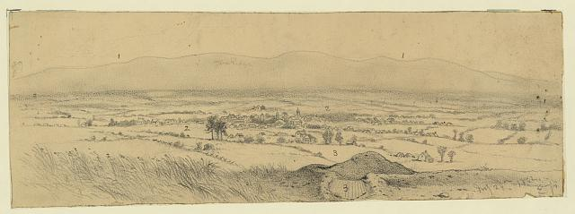
Figure 3. View of Winchester, Va., from fort on the hill N.E. of the town/EF. 1862. Library of Congress
Sharp left Shenandoah Valley traditions to train as a silversmith in Baltimore, Maryland. Sharp would have trained sometime between 1850 and 1857. During this time, the Baltimore silver scene included silversmiths such as Samuel Kirk and George Aiken. Sharp also apprenticed in Baltimore when the city’s silver gained national influence. The rococo revival style rose to popularity, and Baltimore silversmiths relied heavily on the repoussé technique to decorate their pieces. Past scholarship has emphasized the influence of Baltimore silver in the nineteenth century and its influence on Philadelphia silversmiths and southern silver markets. He trained under silversmith Robert Brown. Brown operated his own shop from 1824 to 1849, then went into business with his son, from 1849 to 1852. His son left the business, and Brown continued to work as a silversmith until 1880. Upon the completion of his training, Sharp returned to Virginia for a short period of time before moving to Danville, Kentucky.
According to the 1860 Census, Sharp lived in Danville with the Barbee family. Sharp moved to Danville in 1857 after purchasing the silver shop formerly owned by T.R.J. Ayres. It was during his time in Danville that he made the beaker in MESDA’s collection. Three years after Ayres sold his shop to Sharp, he returned to Danville. Ayres did not approve of Sharp continuing the silversmith shop and acting as though he was his successor. Ayres ran newspaper advertisements against Sharp, but ultimately left the state again. During his time in Kentucky, Sharp married a local woman, Anna Young. The two started their family in Danville as well.
Figure 4. Bicycle Road Map of the Bluegrass Region of Kentucky Louisville. 1899. Kentucky Historical Society. Cropped for detail
Danville at this time had evolved into a primary Bluegrass trade center. Settled in the 1770s, Danville became the first capital of Kentucky. In the 1830s, Danville became a center point of the Maysville, Washington, Paris, and Lexington Turnpike. White settlers migrating out west used the turnpike to get out to the western states. Additionally, the turnpike provided an important point for traders moving goods into the Deep South and the Northeast. After completing his apprenticeship, Sharp could have viewed Danville as a starting point for his career. Despite the Maysville Road veto in 1830, the state of Kentucky still completed the Maysville Turnpike. Sharp might have seen Danville as a center point to import goods while also selling to the town’s growing population and exporting elsewhere in the South. However, at the end of the Civil War, Sharp set his sights on an even larger, Southern market.
Sharp and his family moved from Danville to Atlanta sometime after the spring of 1864. Throughout the first half of the nineteenth century, the explosive growth in railroad connections allowed craftsmen to set up shops in budding cities. The Western and Atlantic Railroad terminus was approved by the State Assembly in 1836, thus sparking Atlanta’s rail boom. In 1845, a second rail company chose Atlanta for its hub. The Georgia Railroad connected Georgians from Augusta to Atlanta. Macon and Western came in one year later and connected the city to Macon and Savannah. Finally, in 1851 the Western and Atlantic Railroad completed the tracks to connect Atlanta to Chattanooga, Tennessee whereby 1854 it was connected to the Nashville and Chattanooga Railroad. By the end of the decade, it was connected by the Memphis and Charleston, and the Knoxville and Virginia lines. The increase in rail lines connecting Atlanta to other major cities set the stage for more people to move into the area, set up businesses and homes, and shape the New South city. Sharp’s migration from Danville to Atlanta illustrates his belief in following transportation networks, from the Maysville Turnpike and major roadways to the many rail lines coming into Atlanta.
Figure 5. Indexed Railroad and County Map of Georgia. 1883. Library of Congress. Cropped for detail
The second item in MESDA’s collection, a silver pitcher, is dated between 1864 and 1870. Although the pitcher features Sharp’s mark, this time with the Atlanta stamp, it also features a second mark. The pitcher was manufactured in Philadelphia, Pennsylvania by the company Krider & Biddle. The manufacturer’s mark is featured in the middle of the pitcher’s bottom, stamped with “K&B” and “925” to indicate sterling silver.
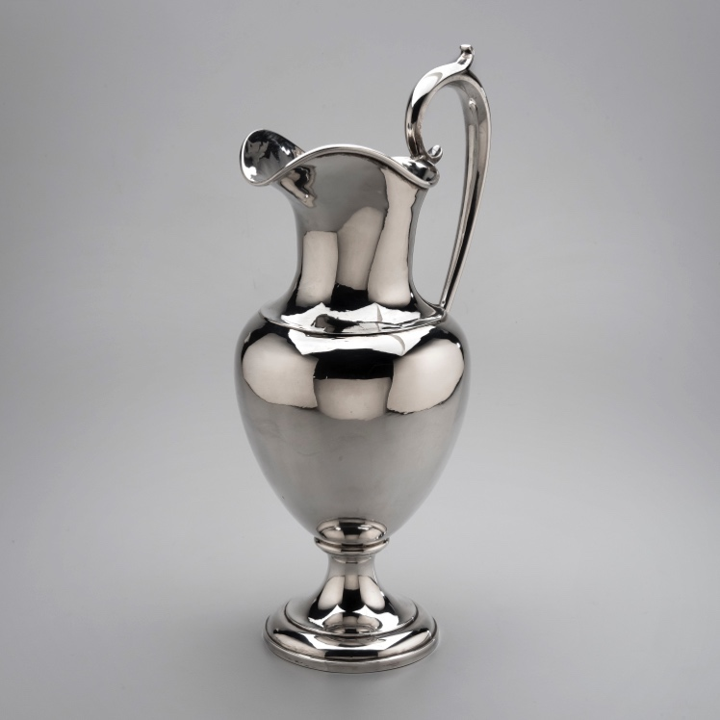
Figure 6. Pitcher by Krider & Biddle, Philadelphia, Pennsylvania, retailed by George Sharp, Jr., Atlanta, Georgia, 1864-1870, MESDA Collection (5976)
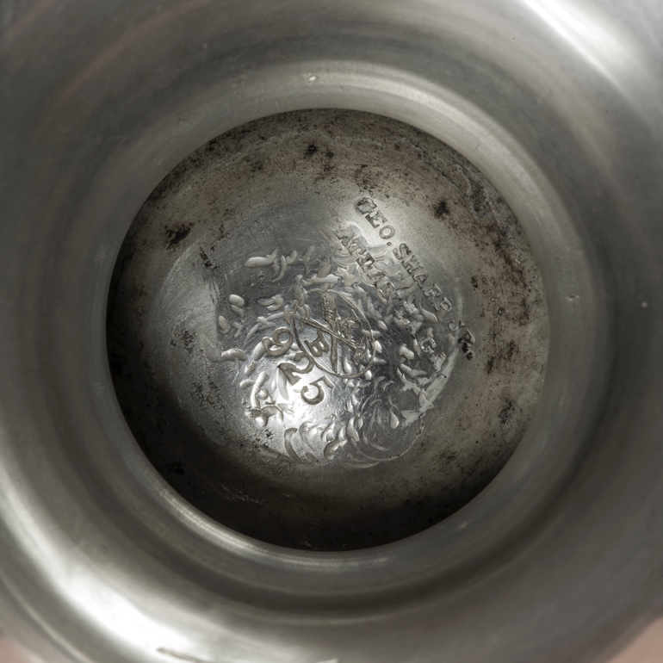
Figure 7. Maker's Mark on pitcher by Krider & Biddle, Philadelphia, Pennsylvania, retailed by George Sharp, Jr., Atlanta, Georgia, 1864-1870, MESDA Collection (5976)
Sharp moved to Atlanta sometime after the war, opening up his shop on Whitehall Street. Interestingly, with the date of the pitcher as 1864-1870, it is worth noting that Sharp potentially received the piece from the Philadelphia manufacturers before the end of the Civil War. However, due to the wartime use and destruction of the railroads, as well as General William T. Sherman’s march through Atlanta, it is likely that Sharp did not retail the Krider & Biddle pitcher until after the war. Northern manufacturers did not lose buildings or material sites during the war in the same way the South did. The southern industry and commerce tried to recover from losing the war, northern manufacturers seized the opportunity to export more goods into the region.
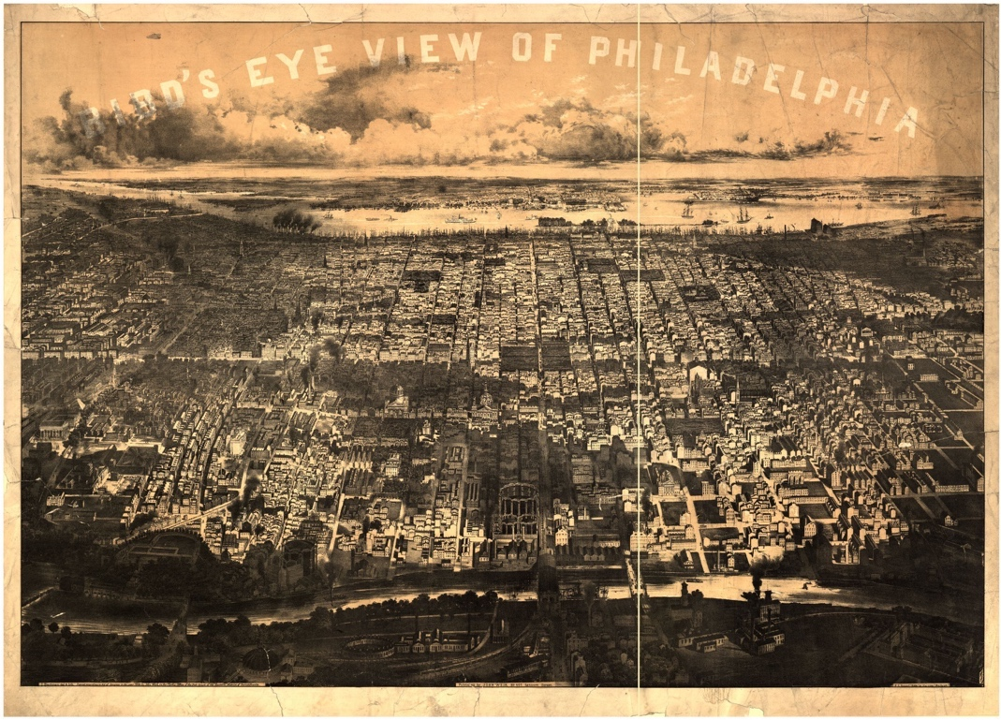
Figure 8. Bird's eye view of Philadelphia. 1868. Library of Congress
Peter L. Krider and John W. Biddle, of Philadelphia, formed Krider & Biddle in 1861. Krider began his career as a silver manufacturer in 1835 when he became the apprentice of John Curry. He briefly worked in Boston for a short period before returning to Philadelphia to open his own silver manufacturing business in 1851. Biddle joined Krider from 1859 until 1870. Biddle left the silver manufacturing business to join his father in the Mine Hill Railroad Company, perhaps lending itself to the business as Krider distributed his goods across the South.
Figure 9. Krider & Biddle Mark on silver cruet, c. 1865, Heritage Auctions
The shift from handcrafting silverwares to importing from manufacturers in the North or beyond can be seen in MESDA’s two Sharp pieces. The beaker made by Sharp in Danville exhibits the seam from where he rolled the sheet to create the cup shape. The banded rims on both the top and the bottom of the beaker were applied by Sharp. While the source of the engraving remains unknown at this time, perhaps Sharp engraved the beaker for the customer while they were in his shop or the customer returned later wanting the engraving. In either case, Sharp’s hand played a role in the creation of the beaker. Yet, possibly not even ten years later, Sharp is primarily importing the goods he sold in his shop. The pitcher, other than his maker’s mark, does not exhibit the work of Sharp as a silversmith. Rather, it displays the work of a manufacturer. The mechanization process of creating and decorating silverwares began prior to the Civil War. Manufacturers could create silverwares at a much faster rate and cheaper price, thus selling pieces wholesale to retailers.
Sharp seized on the opportunity to expand his business network by moving to Atlanta. With the major rail connections running through the city, it would have been more cost efficient for Sharp to get the wholesale pieces from northern manufacturers like Krider & Biddle. Additionally, because of Atlanta’s growth with the railroad, the city would have offered Sharp a larger population to sell his goods to. In 1860, Boyle County, Kentucky, of which Danville is a part of, had a population of approximately 9,300. The same year, Fulton County, Georgia, of which Atlanta is the county seat, had a population of approximately 14,400. Sharp’s shop stood on Whitehall Street, a major artery through the city, which received a significant amount of damage during the war. A newspaper clipping, reprinted in 1898, detailed the damaged stating, “There is not a house standing on Whitehall street from Rowark’s corner to Wesley chapel on Peachtree street.” Perhaps Sharp found a building to open his shop in that remained in the rubble of the block, or moved into a brand new shop as the city began to rebuild.
In the 1870 City Directory for Atlanta, Sharp is listed as a watchmaker and jeweler. Of the six listed jewelers listed, four had shops on Whitehall Street. A fold out map of the city found in the 1870 directory features two advertisements placed by Sharp. One such advertisement reads, “Geo. Sharp, Jr., sole agent in Atlanta for the Jule Jurgensen, Jules Emery, and Edward Perregaux Watches. I left them at imported prices!” The watchmakers Sharp advertised in the directory worked in Switzerland, which showed Sharp’s ability to import from outside of the U.S. and not just from northern manufacturers. Other advertisements placed by Sharp shed light on his reliance on imports.
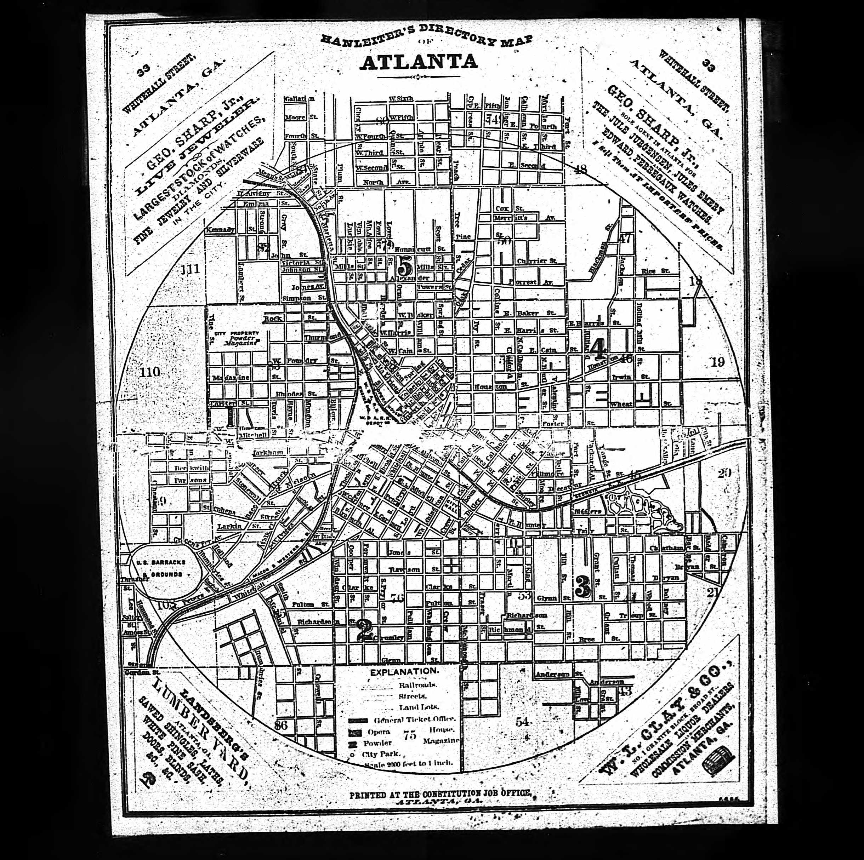
Figure 10. Hanleiter's Atlanta City Directory for 1870, Ancestry.com. Emphasis added.
Sharp clearly experienced success as a jeweler and silverwares importer in Atlanta. In October 1870, Sharp’s advertisement in The Atlanta Constitution reported he won the gold medal for “finest jewelry, silver ware, diamonds and watches at the state fair.” He went on to let buyers know he would sell his award-winning goods at wholesale prices. Even within the city Sharp became the go-to jeweler. In 1871, the Knights Templar Master Masons submitted a letter for Sharp to advertise. In their letter, they stated Sharp provided their group with a solid gold badge which exhibited “a superior piece of workmanship.” Sharp often exhibited his selection of silver goods at the state fair. In 1873, the newspaper ran an article on Atlanta retailers present at the fair. They described Sharp’s entry, which included $40,000 worth of diamonds and jewelry, as “superb.”
In 1871, Sharp took on a business partner, Eugene B. Floyd. The first advertisement under the name Sharp & Floyd appeared in March 1871. Much like Sharp’s former advertisements under his own company name, the advertisement listed the names of import manufacturers from places like Boston and Marion, New Jersey. By April 1871, Sharp and Floyd hired a watchmaker to join the business. G.S. Tait, from Scotland, joined the business as an in-house watchmaker and repairman. The pair announced they would end their business partnership on July 11, 1872, with Sharp asking patrons to continue shopping at Floyd’s for a selection of dry goods.
Sharp’s next step was complicated by the economic panic of 1873. In 1873, Germany ceased to use silver coins, which led to a decrease in the demand for silver in the U.S. The Coinage Act of 1873 replaced the silver policy to a gold standard, caused the price of silver to decline. A scandal over the financing of the Northern Pacific Railroad led to a Wallstreet crash. Additionally, banks began to close as major railroad investors struggled to repay their debts. For Sharp, the panic affected his business two-fold. The pressure on the railroads meant importing wares from his northern manufacturers became more difficult.
Additionally the decrease in silver’s value meant some of his top-selling products did not leave the shelves as quickly as possible. By 1876, Sharp’s advertisements began to use words like “bargain,” “low prices,” and other terminology hinting at financial woes. The decrease in the price of silver, however, meant more people had access to the once luxury good. Silver, which once represented upper-class status and the gentry, could now be purchased by more middle-class families. Additionally, the uses of silver changed as manufacturing became more common. Once used for presentation and show, silver became more frequently used for dining and was not necessarily displayed on the sideboard.
Sharp’s last entry in the Atlanta directory occurred in 1876. He is listed as “diamonds, watches, jewelry, clocks, etc.” with the shop on Whitehall Street. In 1877, Sharp’s wife is listed as “Mrs. George Sharp, Jr.,” still in their home on Pryor Street. A week after his disappearance, the Superior Court in Georgia made a judgment against Sharp. The judgment was for $3,880.35. The company Brainard Steele & Co. had filed a law suit against Sharp on April 12, 1877. The Atlanta Constitution reported the case and stated “There are other large suits against Sharp which will doubtless take the same direction.”
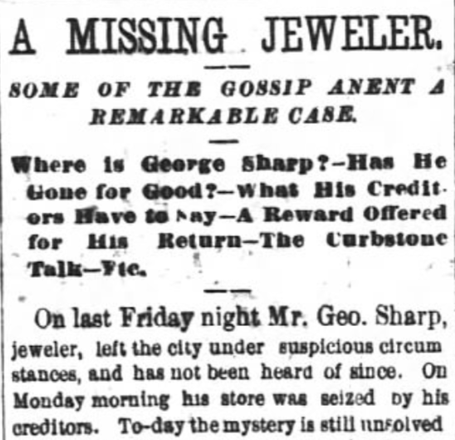
Figure 11. The Atlanta Constitution, 4 April 1877
Yet Sharp had already left town on March 30, 1877. The Atlanta Constitution first reported on the “missing jeweler” five days later. Reporters detailed Sharp’s downfall into debt. They claimed his credit had been impaired and he had been forced to borrow money from friends, not just lenders. They further detailed an exchange between Sharp and one of his loaners. The man claimed Sharp had come to him to propose he would take a trip to Augusta, Georgia to begin selling off the diamonds he had on him. One of Sharp’s employees, Mr. Parks, told the reporter he saw Sharp board a train to Augusta, but had yet to hear from him again. Interestingly, the owner of the local drugstore, Dr. Taylor, told reporters Sharp visited him the day before his disappearance. Dr. Taylor described Sharp as “haggard and miserable” and claimed Sharp even asked about which poisons had the ability to kill the quickest. A Dr. Knott, a second local drugstore owner, corroborated Taylor’s statement and claimed Sharp had inquired with him about poisons as well.
The day after The Atlanta Constitution broke the Sharp story, newspapers in Virginia, South Dakota, Iowa, and Vermont ran a short snapshot on the “absconded jeweler.” A week after he left Atlanta, newspapers in Kansas, Connecticut, Pennsylvania, Delaware, Tennessee, Maryland, New York, North Carolina, Louisiana, Illinois, and Washington, D.C. mentioned Sharp’s disappearance and debt. Perhaps the news spread so quickly to alert Sharp’s many manufacturers of his escape to avoid his debt.
On May 16, 1877, Sheriff Perkerson of Atlanta notified former patrons of Sharp’s store to collect the jewelry they left in his possession for repair. By July of the same year, J.P. Stevens took over Sharp’s former shop on Whitehall Street. Stevens’ advertisement, also in The Atlanta Constitution, boasted “the largest and most complete stocks of diamonds, watches, fine jewelry, solid silver, and plate ware.” In October, the sheriff once again notified citizens of Atlanta of claims to Sharp’s possessions. The land which Sharp owned on Pryor Street, where he took up residence with his wife and two sons, went up for auction in order to satisfy the debts he left upon leaving the city. Reports on Sharp’s disappearance waned as the year passed on.
Despite his initial success as a silversmith and jeweler, Sharp’s story is ultimately one of debt and failure. MESDA’s two Sharp pieces illustrate his fall from fame as one of Atlanta’s top jewelers. Sharp followed advances in transportation in order to boost his business, as seen through his move to Danville along the Maysville Turnpike in Kentucky and to Atlanta during the railroad boom. Sharp, however, did not anticipate the Panic of 1873 nor the Coinage Act of 1873, which devalued silver, one of his major products. His investment in manufactured silverwares meant he purchased goods to stock his store rather than creating his goods by hand, a reflection of the Industrial Revolution and decline in the silver craftsman. The beaker made by Sharp illustrates his early years as a silversmith, making his own products. The pitcher, manufactured by a Philadelphia company then retailed in Atlanta, reveals the struggle southern silversmiths endured during industrialization. Ultimately, Sharp went into debt. Perhaps due to the shift in the creation of silverware and the decrease in silver’s value. Or, as an 1864 advertisement in the Lexington Observer and Reporter reveals, perhaps Sharp had poor business management as he lost a diamond pin and put out a want ad for the return.
At the time of this research project, what exactly happened to George Sharp, Jr. remains unknown. The last mention of his name in newspapers occurred in 1880 when a mysterious advertisement ran in The Atlanta Constitution. The advertisement asked for those curious to remain so, and that “George Sharp, Jr., will be back and give all the information they can ask as to where he has been…” However, no further comment on his potential location ran in the newspaper, perhaps because it went out west to start over. His wife, Ann, listed herself as a widow at some point in the last decade of the nineteenth century. She remained in Atlanta, working as a clerk in various dry goods stores. An obituary for Ann Sharp sheds light on how she remained of high esteem in her community despite her husband’s theft: “The death of Mrs. Sharp carried a message of sorrow especially to the pioneer men and women of Atlanta, all of whom knew her, and many times sang the praises of her heroism in the manner of her meeting of life’s tragedies.” Despite the tragedies of a fallen southern silversmith, at least one Sharp remained at peace. And while we do not know exactly what happened to Sharp, his wife memorialized him even into her death.
Figure 12. Anna Sharp’s grave marker, Danville, Kentucky. Findagrave.net

Bibliography
Primary Sources
The Atlanta Constitution. Atlanta, Georgia.

Hanleiter’s Atlanta City Directory for 1870. Atlanta: William R. Hanleiter Publishing, 1870. Ancestry.com. U.S. City Directories, 1822-1995 [database on-line]. Provo, UT, USA: Ancestry.com Operations, Inc., 2011.

Lexington Observer and Reporter. Lexington, Kentucky.

Sholes’ Directory of the City of Atlanta for 1877. Atlanta: Sunny South Publishing House, 1877. Ancestry.com. U.S. City Directories, 1822-1995 [database on-line]. Provo, UT, USA: Ancestry.com Operations, Inc., 2011.

The Tennessean. Nashville, Tennessee.

United States Bureau of the Census. Seventh Census of the United States, 1850, Winchester, Frederick, Virginia. Washington, D.C.: National Archives.

Secondary Sources
Baltimore Museum of Art, Jennifer Faulds Goldsborough, and Ann Boyce Harper. Eighteenth and Nineteenth Century Maryland Silver in the Collection of the Baltimore Museum of Art: A Project Supported by the Stieff Company, Baltimore. Baltimore: Museum of Art, 1975.

Barreyre, Nicolas. “The Politics of Economic Crises: The Panic of 1873, the End of Reconstruction, and the Realignment of American Politics.” The Journal of the Gilded Age and Progressive Era 10 (2011): 403–23.

Boultinghouse, Marquis. Silversmiths, Jewelers, Clock and Watch Makers of Kentucky, 1785-1900. Lexington: M. Boultinghouse, 1980.

Campbell, Emily. “ “To Please the Most Tasty:” Thomas B. Campbell and Silver for the Great Wagon Road.” Unpublished paper for 2017 MESDA Summer Institute.

Friend, Craig Thompson. Along the Maysville Road: The Early American Republic in the Trans-Appalachian West. Knoxville: University of Tennessee Press, 2005.

Hollan, Catherine. Philadelphia Silversmiths and Related Artisans to 1861. McLean: Hollan Press, 2013.

---. Virginia Silversmiths, Jewelers, Watch- and Clockmakers, 1607-1860. McLean: Hollan Press, 2010.

McDonald, Elizabeth. “I Know What Ewers but What is Mine?” Unpublished paper for 2013 MESDA Summer Institute.

Nelson, Scott Reynolds. “A Storm of Cheap Goods: New American Commodities and the Panic of 1873.” The Journal of the Gilded Age and Progressive Era 10 (2011): 447-453.

Storey, Steve. "Railroads." New Georgia Encyclopedia. 14 September 2018.

Victor, Stephen K. “‘From the Shop to the Manufactory’ Silver and Industry, 1800-1970.” In Silver in American Life: Selections from the Mabel Brady Garvan and Other Collections at Yale University, ed. Barbara McLean Ward and Gerald W.R. Ward. New York: American Federation of Arts, 1979: 23-32.

Ward, Gerald R.W. “‘An Handsome Cupboard of Plate’ The Role of Silver in American Life.” In Silver in American Life: Selections from the Mabel Brady Garvan and Other Collections at Yale University, ed. Barbara McLean Ward and Gerald W.R. Ward. New York: American Federation of Arts, 1979: 33-38.

“Special Card from George Sharp, Jr., Diamond and Jewelry Merchant,” The Atlanta Constitution, 29 July 1876, pg. 4.
“A Missing Jeweler,” The Atlanta Constitution, 4 April 1877, pg. 4.
United States Bureau of the Census. Seventh Census of the United States, 1850, Winchester, Frederick, Virginia. Washington, D.C.: National Archives.
Hollan, Virginia Silversmiths, 692.
Prior research conducted by Emily Campbell, 2017 Summer Institute Fellow, listed the seven silversmiths in Winchester during the first half of the nineteenth century. Campbell utilized the work of Catherine B. Hollan’s Virginia Silversmiths to complete her research on Winchester’s silver scene.
Baltimore Museum of Art, Jennifer Faulds Goldsborough, and Ann Boyce Harper, Eighteenth and Nineteenth Century Maryland Silver in the Collection of the Baltimore Museum of Art: A Project Supported by the Stieff Company, Baltimore (Baltimore: Museum of Art, 1975), 4.
For more information on Baltimore silver and the influence of Samuel Kirk on the nineteenth century silver market, see: Elizabeth McDonald’s “I know what ewers but what is mine?” unpublished paper for the 2013 MESDA Summer Institute.
Baltimore Museum of Art, et al. Eighteenth and Nineteenth Century Maryland Silver, 144.
United States Bureau of the Census. Eighth Census of the United States, 1860, Danville, Boyle, Kentucky. Washington, D.C.: National Archives.
Marquis Boultinghouse, Silversmiths, Jewelers, Clock and Watch Makers of Kentucky, 1785-1900 (Lexington: M. Boultinghouse, 1980), 241.
Boultinghouse, 241.
Craig Thompson Friend, Along the Maysville Road: The Early American Republic in the Trans-Appalachian West (Knoxville: University of Tennessee Press, 2005), 2.
On April 13, 1864 Sharp placed an advertisement in The Lexington Observer and Reporter asking for the return of several lost diamonds. This article places Sharp in Kentucky as late as April 1864, while the pitcher in the MESDA collection dates the pitcher retailed by Sharp as 1864-1870.
Steve Storey. "Railroads," New Georgia Encyclopedia. 14 September 2018.
Catherine B. Hollan, Philadelphia Silversmiths and Related Artisans to 1861 (McClean: Hollan Press, 2013), 110.
Hollan, Philadelphia Silversmiths, 19.
For more information on the shift from silversmithing to silver manufacturing see: Stephen K. Victor’s “‘From the Shop to the Manufactory’ Silver and Industry, 1800-1970,” in Silver in American Life: Selections from the Mabel Brady Garvan and Other Collections at Yale University, ed. Barbara McLean Ward and Gerald W.R. Ward (New York: American Federation of Arts, 1979), 23-32.
“Atlanta When it was Left in Ashes,” The Atlanta Constitution, 24 July 1898, pg. 7.
Hanleiter’s Atlanta City Directory for 1870 (Atlanta: William R. Hanleiter Publishing, 1870), 287-288.
Hanleiter’s Atlanta City Directory for 1870ˆ, 287-288.
“$75,000 in Gold,” The Atlanta Constitution, 26 October 1870, pg. 3.
“Knights Templar – Master Masons,” The Atlanta Constitution, 24 May 1871, pg. 3.
“Atlanta at the Fair,” The Atlanta Constitution, 29 October 1873, pg. 3.
“Railroad Men Take Notice,” The Atlanta Constitution, 17 March 1871, pg. 2.
“Fine Watch Repairing!,” The Atlanta Constitution, 4 April 1871, pg. 4.
“Notice,” The Atlanta Constitution, 11 July 1872, pg. 3.
Scott Reynolds Nelson, “A Storm of Cheap Goods: New American Commodities and the Panic of 1873,” The Journal of the Gilded Age and Progressive Era 10 (2011): 447.
Nicolas Barreyre, “The Politics of Economic Crises: The Panic of 1873, the End of Reconstruction, and the Realignment of American Politics,” The Journal of the Gilded Age and Progressive Era 10 (2011): 403–23.
For more information on the changing roles of silver in American life from the 1650s through the twentieth century see: Gerald W.R. Ward, “ ‘An Handsome Cupboard of Plate’ The Role of Silver in American Life” in Silver in American Life: Selections from the Mabel Brady Garvan and Other Collections at Yale University, ed. Barbara McLean Ward and Gerald W.R. Ward (New York: American Federation of Arts, 1979): 33-38.
Sholes’ Directory of the City of Atlanta for 1877 (Atlanta: Sunny South Publishing House, 1877), 303.
“Atlanta Constitution,” The Tennessean, 12 April 1877, pg. 3.
“A Missing Jeweler,” The Atlanta Constitution, 4 April 1877, pg. 4.
“Claim Your Jewelry,” The Atlanta Constitution, 16 May 1877, pg. 4.
“Opening of the Magnificent New Store of J.P. Stevens & Co.,” The Atlanta Constitution, 22 June 1877, pg. 4.
“Marshal’s Sales for November 1877,” The Atlanta Constitution, 30 October 1877, pg. 3.
“Lost---$100 Reward,” Lexington Observer and Reporter, 13 April 1864, n.p.
“George Sharp’s Whereabouts, The Atlanta Constitution, 17 October 1880, pg. 1.
For the city directories in which Mrs. Anna or Ann Sharp is listed, 1894 is the first available directory to list her as a widow.
“Funeral of Mrs. Sharp,” The Kentucky Advocate, 5 July 1916, p. 3.

